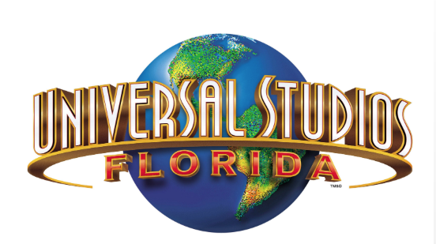
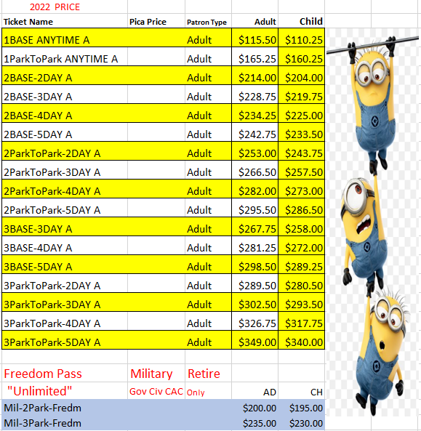
NOTE: All Tickets are NONREFUNDABLE and nontransferable. Prices and entitlements are subject to changes without notice.
Leisure Travel Service LTS/ITR Building 3150 New Location GYM 973-724-4014/5515

2022 2022

